Conﬁdential / September 2021

Proposal prepared for
MI STATEWIDE INDEPENDENT LIVING COUNCIL

Idea39, LLC
2937 E Grand Blvd
Detroit, MI 48202

Web: idea39.com
Phone: 313.644.2048
Email: hello@idea39.com

Woman-Owned Small Business
EIN: 87-368962
In good standing with the State of MI

Michigan SILC Changemakers and Advocates,

Before we begin, thank you for the opportunity to respond to your RFP, which I found through the Michigan Nonproﬁt Association’s website. I started Idea39 because I want to help organizations like yours change the world, and making our society more inclusive and accessible is a critical mission with personal ties for me.

My aunt, whom I was close to all my life, was a quadriplegic from the age of 17 after a cataclysmic car crash. With help from organizations like MI SILC, she was the ﬁrst in our family to go to college, she launched a fulﬁlling career as an accountant, and she lived independently in a home she and my uncle—also a person with disabilities—built and modiﬁed together. My aunt was determined to live life on her own terms. I’m grateful to have known her and for the way she inspired me to always strive for more, no matter the odds.

People with diverse abilities deserve to participate fully in our communities and our nation, and independent living is a key step. This is the kind of cause that gets me and my team out of bed in the morning and drives us to keep creating and innovating with our whole hearts. We will bring creativity, strategy, and decades of collective advertising and marketing experience to this project so Michigan SILC can keep doing the boots-on-the-ground work helping people thrive independently. With livelihoods on the line, you have to get this right—and our team is ready to hit the ground running.

Enclosed please ﬁnd our proposal for the work speciﬁed in your RFP. Our hope is to spend the next several months executing ﬁnely tuned media and communications plans to meet your wildest goals and targets. We’re up for the challenge and eager to support your incredible mission.

Looking forward to working together,

Adrienne Pickett
Founder / Chief Creative Oﬃcer

3

table of contents
5. Why We’re Here
6. Your Asks & Our Approach
9. Estimate
11. Our Team
19. Our Work
25. References

4

why we’re here

If you want to change the world, you need people in your corner. You need to cut through the clutter. And you need to win hearts and minds. How? Let us show you.

At Idea39, we’ve turned grassroots candidates into household names and helped hyper-local nonproﬁts create brands that would make Corporate America jealous. And we’re just getting started.

We combine forward-thinking design, thoughtful content, full-service campaign leadership, project management and intuitive strategy to help NGOs and nonproﬁts succeed. With over 100 campaigns under our belt in Michigan and beyond, you won’t ﬁnd a team that has our comprehensive experience and approach anywhere else.

Each organization and cause demands a unique game plan to make the most of a limited marketing budget. With diverse media and marketing tactics, we can help you raise awareness about your services and community impact, inspire new partnerships, and support underserved disability populations. Our customized media and communications strategy will connect with multiple audiences at once and enhance the important work you do every day.

5

your asks
Support MI SILC’s mission by:

Creating, implementing, and evaluating a comprehensive statewide outreach plan to increase awareness of IL/CIL services among unserved and underserved disability populations in Michigan.

Developing accessible informational and educational materials about IL and CIL service awareness. Then, disseminating them across multiple accessible platforms including social media, websites, and in key partner locations where targeted minority and rural populations receive goods and services.

Developing and launching a targeted outreach social media presence.

Developing community presentations, materials, and talking points.

Increasing SILC partnerships with disability-related community service agencies and groups in targeted areas.

Developing a SILC newsletter template and informational materials to be distributed to partners and individuals to increase community awareness of Independent Living, the Centers for Independent Living, and SILC.

Training SILC staﬀ on managing an eﬀective social media presence.

Assisting in direct communication eﬀorts to the public including the development of a mailing list.

Evaluating the eﬀectiveness of the outreach plan.

6

our approach
Creating a marketing and PR plan that is eﬀective and aﬀordable can be a daunting task, but connecting your organization seamlessly with many audiences is part of what we do. Our planned approach is ﬂexible by nature—giving us room to meet all your goals while being transparent, nimble, timely, and aﬀordable.

We will…

Workshop with you on WHO your audiences are and HOW and WHERE they are interacting with you.

Develop a well-designed communications and media plan that leverages all your available assets, identiﬁes new and aﬀordable opportunities, creates informational and educational materials, newsletter, and a 6-month calendar and plan that everyone can stick to.

Implement a robust project management system to help prioritize all deliverables in a timely manner.

Organize, copyedit, and/or make recommendations for your existing content to achieve the best search results, social engagement, and overall metrics.

Create an impactful social media calendar and content and manage all posts, advertising, and engagement in a timely matter.

Meet and partner with you bi-weekly to manage requests, do trainings, review work, share analytics, and understand your needs.

Create a PR plan that is easy to follow and makes recommendations for HOW to get the message out with earned media, partnership opportunities, and other communities of interes

7
by the numbers

aor retainer estimate / contract period 11.1.21 – 5.1.22
65 Hours a Month for Creative Direction, Social Media Management, Content Copywriting, Design, Website Design, Strategy Consulting, Project Management, and PR

10 Hours / Creative Direction and Strategy
16 Hours / Account + Project Management
6 Hours / Social Media
6 Hours / Design
12 Hours / Copywriting + Editing
7 Hours / Website Help
8 Hours / PR

TOTAL AGENCY ESTIMATE/MONTH $ 4,906.25*
POTENTIAL DIGITAL MEDIA BUDGET $15,000.00

*Payments are due on the first of the month for the following months work. Billing is NET 15 days from receipt of invoice. Scope in this estimate includes 3 rounds of revisions. More than 3 revisions will constitute a rate of $100 an hour. Scope creep past the 41 hours a month will be invoiced at $100 an hour after notification of hours. Please note hard cost materials from outside vendors, printer pricing, paper stock, photography (including stock), photographers, stylists, domain hosting, domain purchase, specialized typography, etc. are not included in the budgets outlined on these pages and may require payments directly to those contracted vendors. Any media buys including print, digital or out of home are a separate cost and not included in this estimate.

our org

your team
Meet the faces behind your communications eﬀorts. Our talent is seasoned and scrappy, local and resourceful for just the right ﬁt for you.

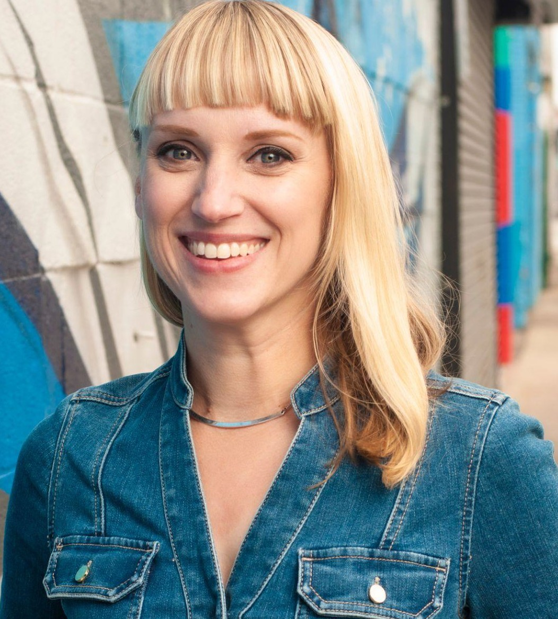
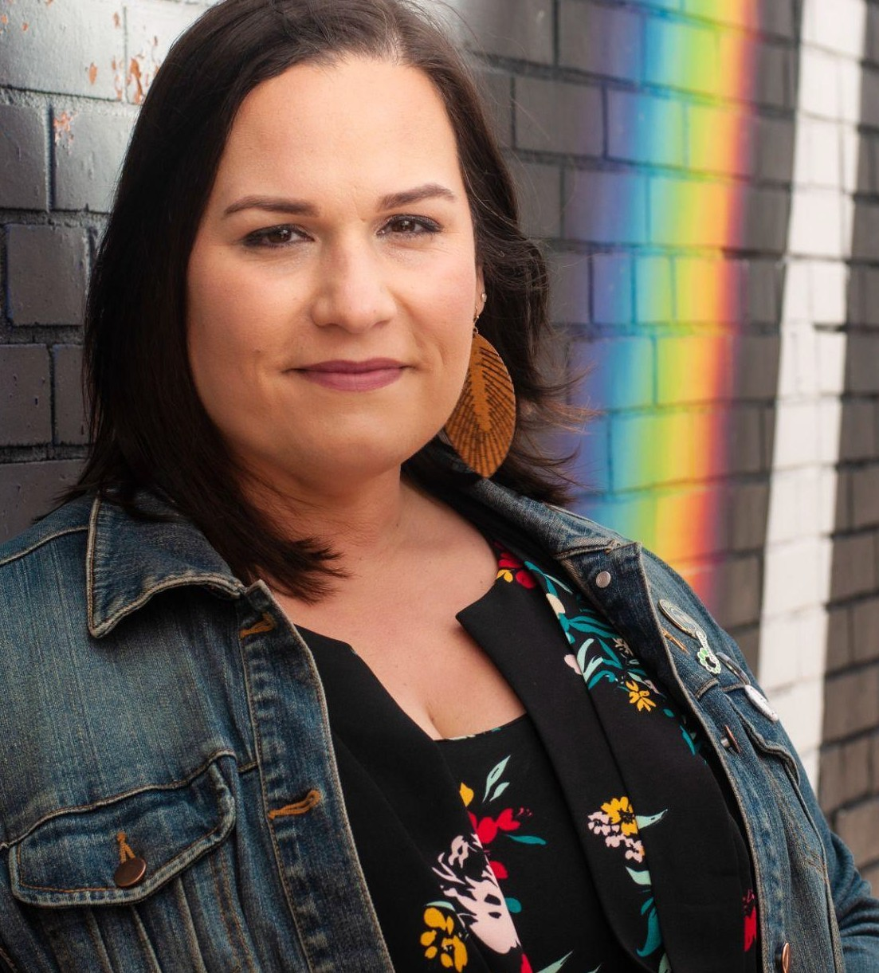
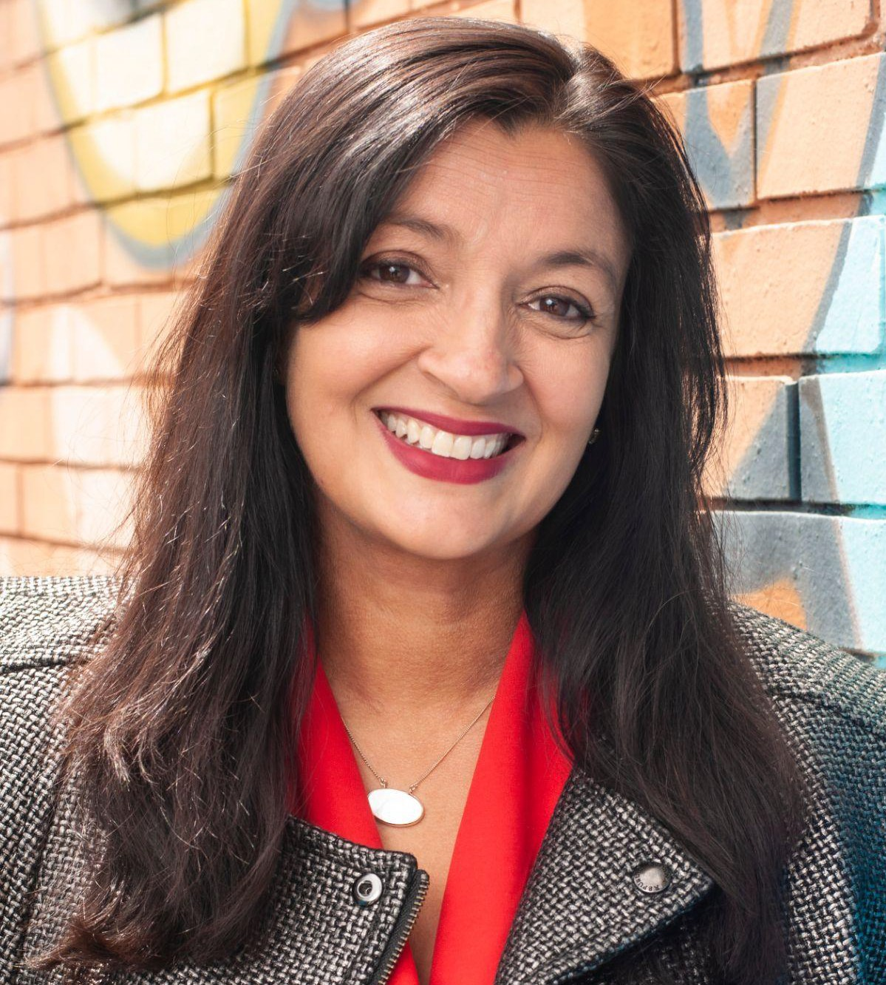

Adrienne Pickett
Founder / Creative Director Throughout Adrienne’s 20-year career, she has created a variety of award-winning
work for some of the world’s largest billion-dollar brands and companies.
Strategic and insight-informed art direction, branding, identity, web, TV, and guerrilla marketing are her specialties.

Adrienne earned her BFA with a concentration in graphic design and history from the University of Michigan. Her work has won coveted awards through Graphis, ADCD, and The Eﬃes.

She’s also an accomplished artist, illustrator, and muralist putting her talents to use in SE Michigan.
Emilie Rohrbach
VP / Campaign + Project Management Self-described “cat herder,” world traveler, and mother of three, Emilie Rohrbach of Madison Heights was recently the formidable campaign manager for Kelly Breen for State Representative.

She earned her Master’s Degree from Oakland University and throughout her career has steered various national and local non-proﬁts, helping them with everything from fundraising
to marketing and community engagement.

Not only does Emilie bring her vast experience to Idea39 as a campaign manager, but she’s also been a candidate herself. An Emerge grad, she also serves on Madison
Heights City Council.
Amani Johnson
Field + Campaign Strategy Southﬁeld resident, School Board Trustee, and graduate of Central Michigan University, Amani Johnson has a passion for public service.

Amani’s experience has taken him to the Michigan House of Representatives as a legislative aide, a ﬁeld director for Jim Haasdma, and as a ﬁeld organizer for the Elizabeth Warren for President campaign.

When not working to make the world a better place, Amani enjoys spending time with his boyfriend, good BBQ ribs, and traveling.
Sonia Patel
New Business / PR
A native of Jackson, Sonia is a recent Ford PR executive, Mothering Justice Fellow, Michigan State MFA grad, Canton Democratic Club President, and now brings her talents to Idea39.

She received her Bachelor’s and Master’s degrees in Communications from Michigan State University.

Sonia has lived and traveled the world, loves bad Hindi movies and can regale you with stories about the one time she had to take Russell Crowe to dinner.

14

your team
Meet the faces behind your communications eﬀorts. Our talent is seasoned and scrappy, local and resourceful for just the right ﬁt for you.

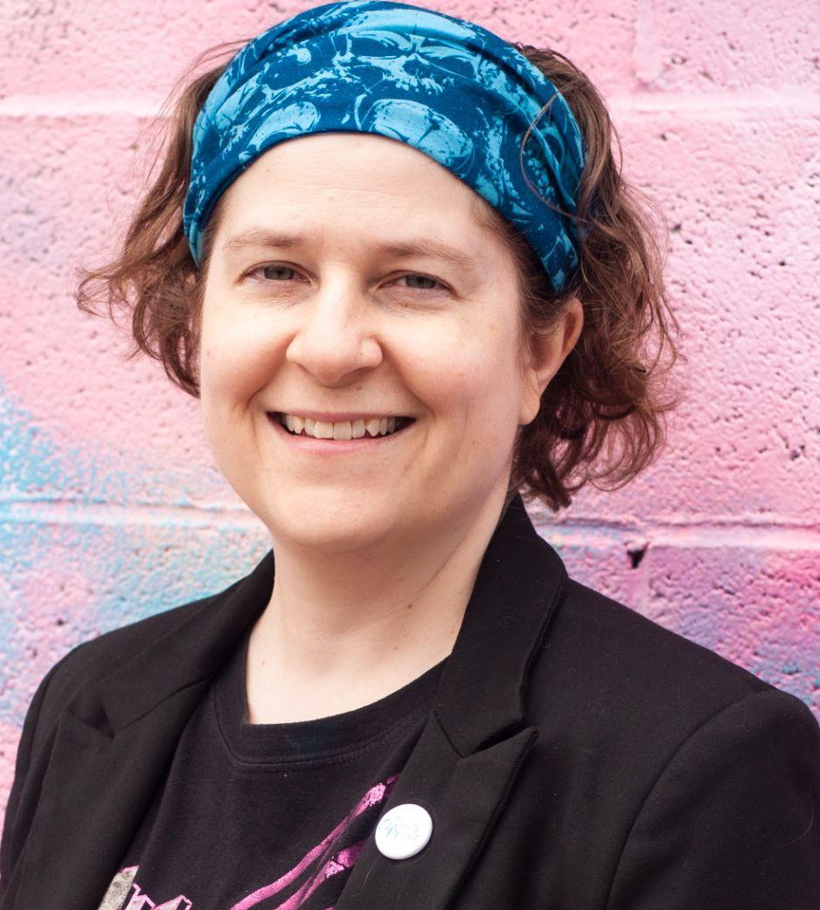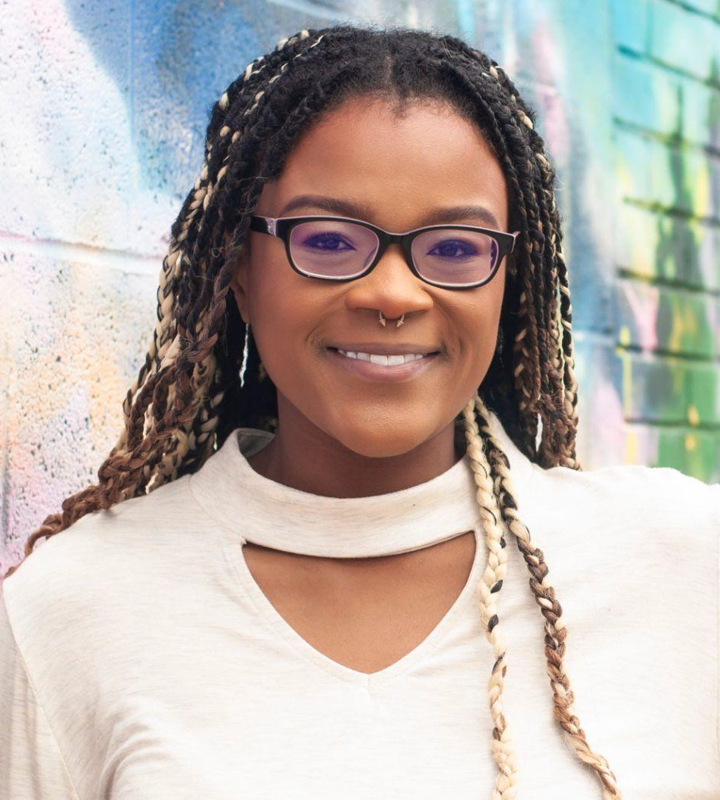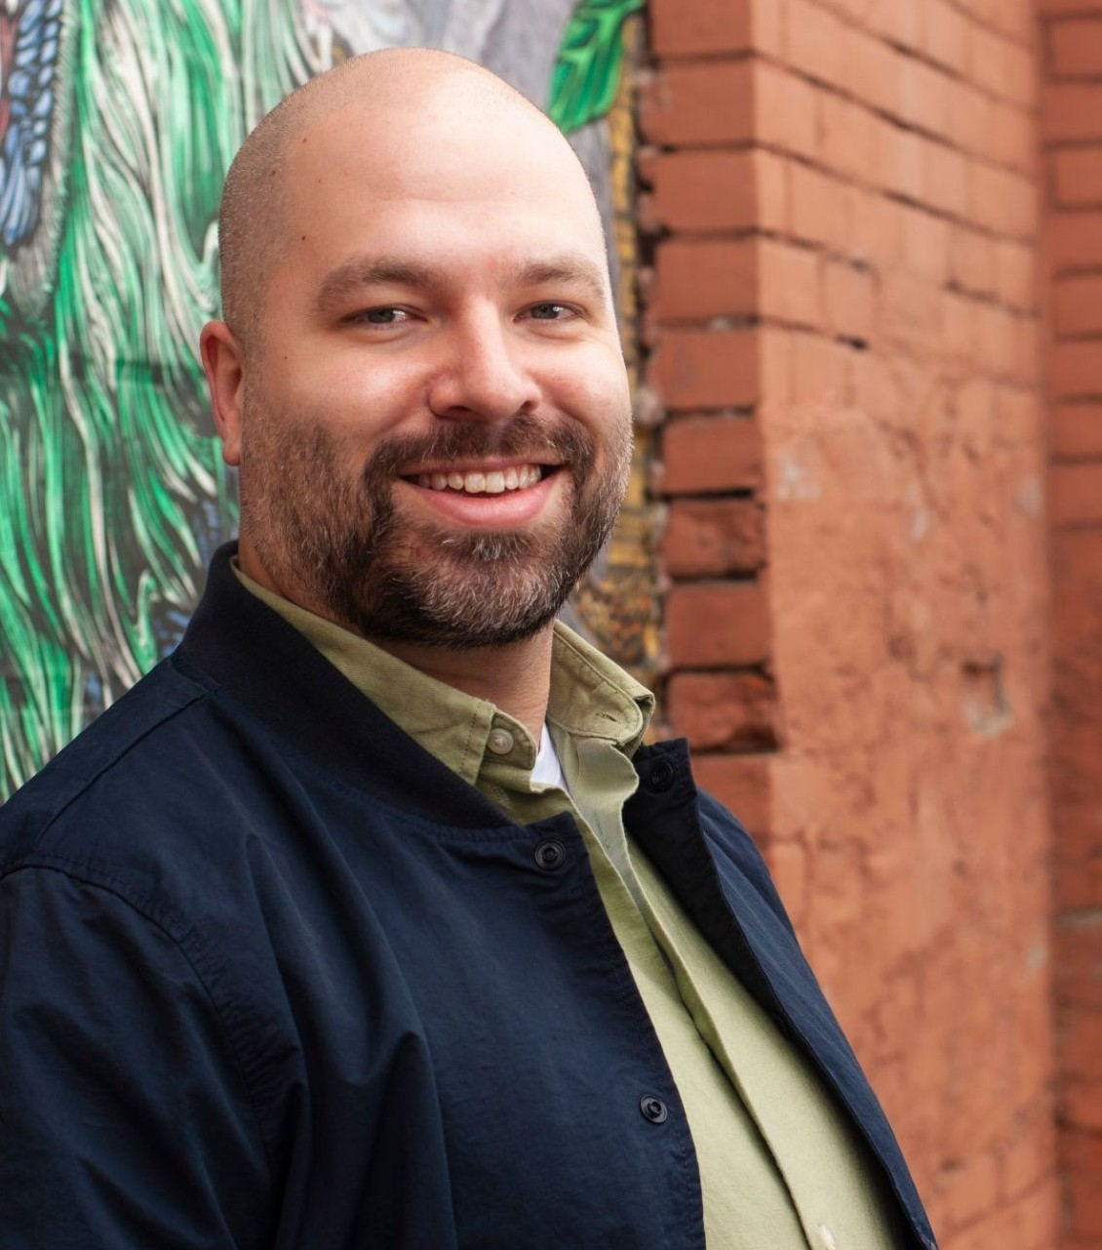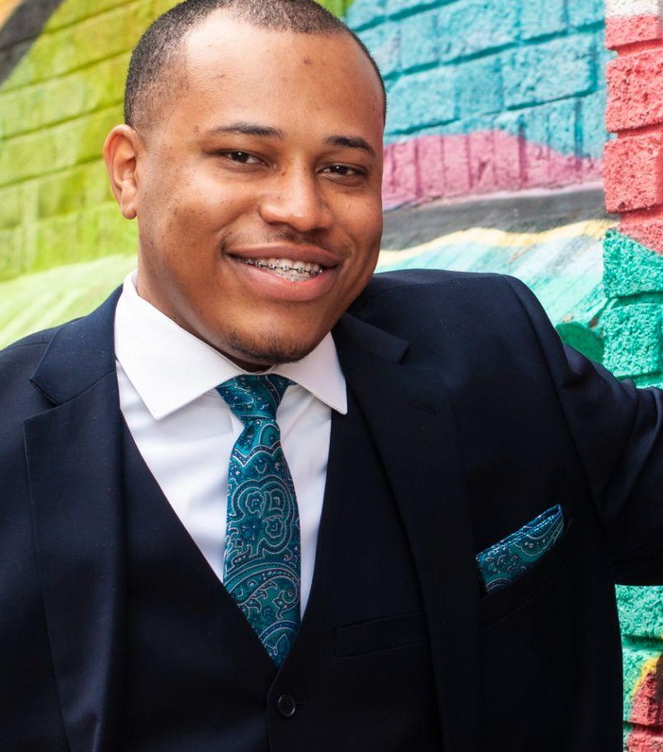

Holly Ellis
Creative Copywriter
A graduate of Kalamazoo College, the University of Michigan’s School of Social Work, and a former Presidential Management Fellow, Holly has worked as a copywriter, program analyst, and administrative manager for a wide range of public and private organizations. She spent eight years of her career creating high-proﬁle documents for executive leaders at the Department of Veterans Aﬀairs and has since written for the healthcare, legal, transportation and logistics, government, and entertainment industries.

When she’s not creating impactful content, Holly enjoys going on adventures with her husband and two children.
D’Anne Witkowski
Creative Copywriter
Writer, teacher, and organizer, D’Anne brings over a decade of experience writing about politics and LGBTQ issues with an emphasis on Michigan to Idea39.

D’Anne has a variety of background interests and policy knowledge including health care access, reproductive rights, comprehensive sex education, sexism, racism, economic inequality, voting rights, criminal justice reform, and public education.

She also writes a nationally syndicated column called “Creep of the Week” for LGBTQ publications, loves metal music, and the smell of new books.
Amethyst Stewart
Social Media Manager
Recent graduate of CMU and avid world traveler, Amethyst Stewart is passionate about using social platforms and design for change. She led the Committee for Anti-Racism at CMU and through her research and collaboration with other board members was able to get Central declared an anti-racist institution.

She’s been working on local campaigns and podcasts and loves spending time with her family and eating Fruity Pebbles all while watching Bob’s Burgers.
Jason Rodriguez
Designer
Jason has been working in the realm of design, communications, and digital going on 14 years. He’s published his own books, traveled the world, and is committed to making change through design.

Jason is also an accomplished musician and has headlined the House of Blues in Chicago. He once texted “wish me luck.
I love you.” to the founder of a company before a job interview. A message that was clearly meant for his wife. He got the job.
Kevin Johnson
Deputy Field Director
Eastern Michigan University political science major Kevin Johnson discovered his love for politics after Donald Trump was elected. He worked as a Field Organizer across several campaigns for State House and State Senate and continues to expand his knowledge into all facets of running campaigns.
He’s currently enrolled in the Great Lakes Political Academy, loves data, and is passionate about the grassroots initiatives that drive change.

He’d also like to be referred as Jedi Master, solved three sides of a Rubik’s Cube once, and hates chocolate.

15

our process

OUR SOCIAL MEDIA PROCESS

CREATE QUARTERLY CALENDAR

Look for relevant national holidays, identify trends and articles, work with client on company milestones, hashtags

Copywriter creates content

Suggest Media Buy for speciﬁc posts or standalone ads

Share quarterly calendar and content with client for approval

Make any necessary changes

Once approved, schedule out 3 months of posts in Hootsuite

Identify any quickturn articles or pace of media
for sharing

Find which posts are performing best for boosting

Keep the conversation moving with call and response, invites to like/follow

our experience
Our unique range of marketing, media, events, PR, and nonproﬁt experience has led to successful partnerships with incredible organizations across Michigan and the country working to make positive changes in their corners of the world.

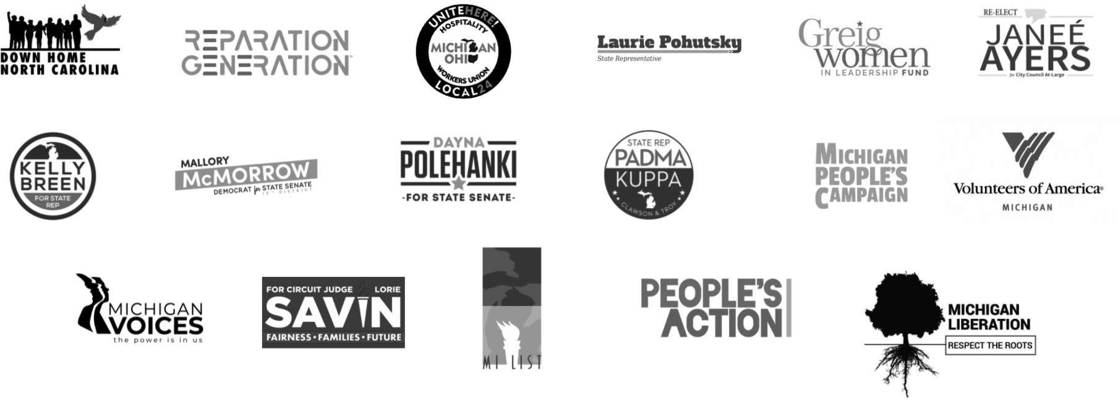

18

our work

GREIG WOMEN IN LEADERSHIP FUND

“why i lead” / “100 years of suffrage” / “how i lead”
campaigns for greig women in leadership fund

“Did you know there were more men named Mike in the Michigan Senate than there were elected women?” - Christine Greig

When House Democratic Minority Leader Christine Greig approached us to help bring her fund to life, we jumped at the chance to support women candidates. We created an eclectic campaign complete with
12-month social media calendar, unique content, beautifully produced videos, and several promotional events, including:

A panel and screening after the primary at Birmingham’s Maple Theater

An ice cream picnic celebrating the 100th Anniversary of the ratiﬁcation of Women’s Suffrage and featuring U.S. Representatives Brenda Lawrence (MI-14) and Haley Stevens (MI-11)

A mega-donor event with one year to go until the 2020 election.

All of this to ﬁght for something everyone should support: more women representing us in government.

The results spoke for themselves: A 100+% increase in engagement on the GWILF’s social media platforms, tons of small donations that added up to over $45,000 for the fund to give back to campaigns, and more than half of her featured candidates elected to oﬃce.

MI VOICES
“Voices for vaccines”

MI Voices recently contacted us to launch a statewide campaign focused on promoting COVID-19 vaccination within under vaccinated communities
of color around the state. We developed themes that challenged misinformation while addressing the fears and reservations prevalent within our target audiences. The scope of our project included:

Concept Development

Door to door canvassing in communities across
Michigan vaccinating people on the spot or coordinating to get them to locations nearby

Print materials Website Design
PR Assistanc

MI LIST
When the legendary Barb Fuller of MI List approached us about helping to grow their social media feeds and generate buzz for their annual Great Women of the Great Lakes fundraiser featuring Governor Gretchen Whitmer, we were beyond thrilled to jump in.

We wanted to honor the legacy of the last 15 years of MI List with beautiful invitations, print materials, and of course, a robust social media strategy on Facebook and Instagram. We created visual interest with eye-catching custom illustrations, some of which became animations that comprised a video played for attendees at the event. You can watch the video now on their Facebook page @milistpac.

After it was all said and done, our social media strategy doubled their likes and follows, helped pack the room at GWGL with supporters (including Governor Whitmer, Congresswoman Debbie Dingell, and MDP Chair, Lavora Barnes), and attracted new donors, bringing in more than
$13,000 in additional funding to the PAC.

PEOPLE’S ACTION
People’s Action, a broad coalition of local and state organizers representing multi-racial and
multi-generational working people, reached out to Idea39 after they saw our game-changing work for the Michigan People’s Campaign 2018 Governor’s Forum. They needed help with print, digital, and event materials for a massive press event at the National Press Club in Washington DC.

“The Promise of a Progressive Populist Movement” became THE event to be seen and heard at with Senator Jeff Merkley, Judith LeBlanc, Director of the Native Organizers Alliance, and the Center for Rural Strategies headlining. Our big, bold graphics and annual report caught everyone’s eye, and we helped People’s Action garner earned media attention in The Nation, among others.

UNITE HERE! LOCAL 24
We worked alongside Unite Here! Local 24, the nation’s largest hospitality workers union, to create a 360 campaign to support their friend and fellow union member, Charlesetta Wilson, and her bid for the 6th House District.

We created refreshing content, simple videos featuring supporters, social media, direct mail, an SEM campaign, Spotify, YouTube, and digital placements all driving to one attractive and user-friendly website.

We generated nearly 300,000 impressions and reached over 20,000 people via Facebook, garnered 224,350 impressions via digital, and served over 81,000 ads on Spotify. Although she didn’t win, she did come in a very close 2nd place, outranking 10 other people in a crowded ﬁeld littered with name recognition.

references

Sommer Foster
Director, MI Voices
P: 734-216-7385 E. sommer@michiganvoices.org

Representative Christine Greig - HD37 Former Michigan House Democratic Minority Leader Senior Advisor, Lawmaker Engagement Future Now
P: 810-444-7406 E: chris_greig@msn.com

David Mayer
Co-Chair, Founder Reparation Generation
P: 510.915.1687 E: dmayer1645@gmail.com

Barb Fuller
Founder and Chair, MI List
P: 734.646.5100 E: barb@provide.net

Adam Kruggel
Director of Strategic Initiatives, People's Action
P: 510-982-9131 E.kruggel@peoplesaction.org

Sommer Foster
Director, MI Voices
P: 734-216-7385 E. sommer@michiganvoices.org

25

Idea39, LLC
2937 E Grand Blvd
Detroit, MI 48202

Web: idea39.com Phone: 313.644.2048
Email: hello@idea39.com

Woman-Owned Small Business
EIN: 87-3689628
In good standing with the State of MI

