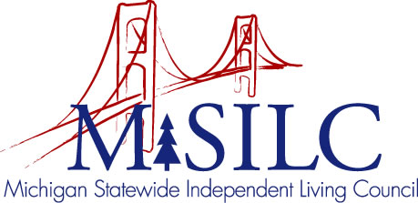

OPEN MEETINGS NOTICE
OUR VISION

To Champion systemic change creating inclusive communities across the state for all Michigan citizens.

SPIL MISSION

To promote independent living opportunities across all spheres of life.

The SILC Membership
is pleased to announce their upcoming
Strategic Planning Retreat Part II

July 10, 2021
Zoom Teleconference Meeting

Time: 10:00 a.m. - 2:00 p.m.

Call In: 1-646-558-8656
Meeting ID: 894 8274 1058

Join Zoom Meeting
https://us02web.zoom.us/j/89482741058

NOTE: To be responsible stewards of public funds, we ask that if you plan to join us for lunch, you contact our office at: 517.371.4872 – local or 833.808.7452 – toll free

