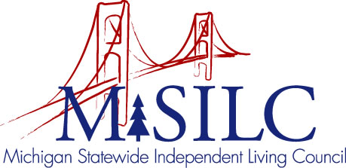

OPEN MEETINGS NOTICE
OUR VISION

To Champion systemic change creating inclusive communities across the state for all Michigan citizens.

SPIL MISSION

To promote independent living opportunities across all spheres of life.

The SILC Membership
is pleased to announce their upcoming
Business Meeting

June 25, 2020
Zoom Teleconference Meeting

Quarterly Business Meeting: 12:00 p.m. - 1:00 p.m.

Call In: 1-646-558-8656
Access Code: 832 4432 6092

NOTE: To be responsible stewards of public funds, we ask that if you plan to join us for lunch, you contact our office at: 517.371.4872 – local or 833.808.7452 – toll free

NOTE: If you need reasonable accommodations to participate in this meeting, please contact our office no later than Friday, June 19, 2020.

